**Personalized marketing and targeted advertising**

**Problem Statement**

The rapid pace of innovation in the field of Artificial Intelligence (AI) is turning the far-fetched dreams of yesterday into advances of today. Artificial intelligence matches our desires with the exact information, product or service we need, at the right time. It is increasingly being used to improve search results, and it will be the driving force behind the changes in content production, target marketing and advertising.

Personalization based on data has become critically important in digital marketing [1], but many marketers still use outdated methods, with business rules created through online analysis of collected data.

These rules are implemented in an automated way via a business rules engine the accumulates all the rules over time, including old efforts that no longer work. This process is very inefficient for driving customer acquisition, conversion and retention effectively.

**Background**

**Personalized marketing with machine learning [1][2]**

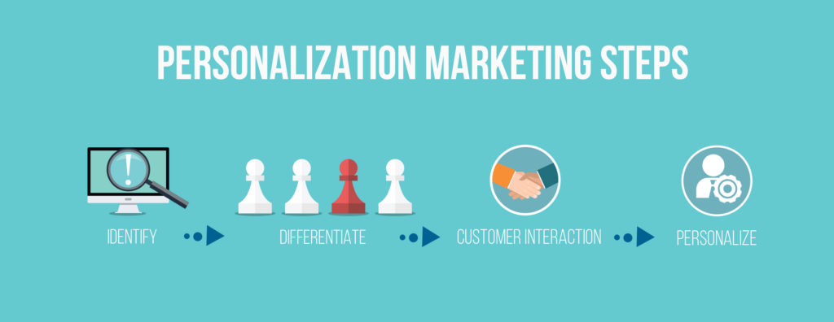

The approach for personalized marketing used by the most successful digital companies (Google, Netﬂix, Instagram, Twitter) is machine learning. Self-learning sense-and-respond systems do the challenging work of analyzing data and writing business rules in real time. Once these rules are applied, the data analytics system evaluates the efficacy of the rules based on success or failure, and adjusts accordingly. This way, the rules evolve and improve over time, continually advancing business outcomes by delivering insights for marketers.

**Advertising using Artificial Intelligence and Deep Learning**

<https://www.rtbhouse.com/deep-learning-leads-to-ultra-precise-personalization/>

Deep learning is the next major area of AI-based research, and it will bring a new era of marketing, which both advertisers and end-users will benefit from.

For example, Facebook has an abundance of data from its users which, when mined intelligently, can uncover hidden patterns. Such information can be implemented properly into content creation, marketing strategy or advertising targeting to give users the most efficient information, tailored and customized through AI.

Furthermore, a recent announcement by Coca-Cola indicates that they want to use AI bots to create music for ads, write scripts, post on social media, and buy media – implying that the deep learning ads' revolution seems closer than ever.

**Methodology**

Personalized marketing is dependent on technology for data collection, data classification, data analysis, data transfer, and data scalability. Technology enables marketing professionals to collect first-party data such as gender, age group, location, and income and connect them with third-party data like click-through rates of online banner ads and social media participation.

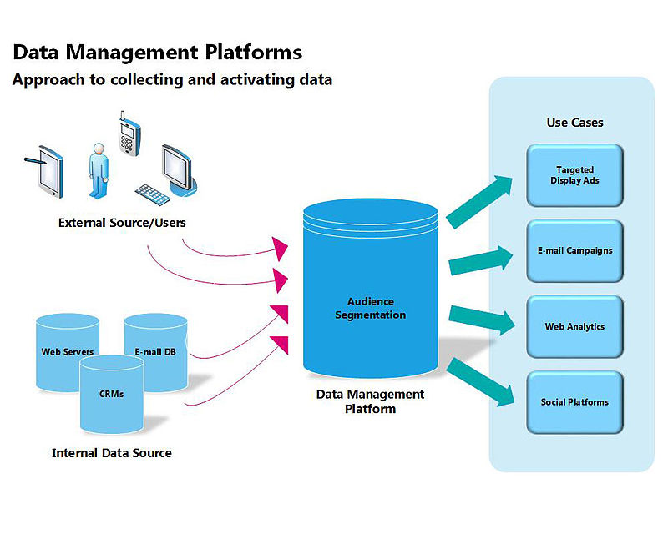

Fig1: Example of data collection[3]

Having knowledge of the consumer's preferences enables suggesting specific products and promotions to each consumer. One-to-one marketing is based in four main steps in order to fulfill its goals:

**Identify**: To collect reliable data about the preferences of the customers of the company.

**Differentiate**: To distinguish the customers in terms of their lifetime value to the company, their priorities and needs and to segment them into more restricted groups.

**Interact**: To get the customer's attention by engaging with him through the communication channels and in ways that he enjoys the most.

**Customize**: To personalize the product or service to the customer individually using the knowledge that a company has about a customer via machine learning and deep learning tools.

**Experimental Design**

*Step 1: Data collection and dataset preparation*

The data set can be generated from specific company or downloaded from www.kaggle.com.

*Step 2: Developing a recommender system based on predictions*

A structured DNN will be trained for predictive analytics. Also, feature design and selection

will be done using various machine learning approaches like Linear Regression, SVM, Random Forest, k-Nearest Neighbors (kNN) etc.

*Step 3: Training and experimentation on datasets*

The recommender model will be trained for the chosen dataset.

*Step 4: Deployment and analysis on real life scenario*

The trained and tested recommender system will be developed in real-life scenario.

**Experimental Design**

*Dataset*

The dataset from some company will be used for experimentation.

*Evaluation measures*

Measures such as accuracy will be computed by comparing the desired satisfaction for level of marketing and advertisement.

*Software and Hardware Requirements*

Deep learning libraries will be exploited for the development and experimentation of the project. Training will be conducted on NVIDIA GPUs for training the DNN model.

**References**

1. <https://scholar.google.co.in/scholar?q=Personalized+marketing+and+targeted+advertising+using+machine+learning&hl=en&as_sdt=0&as_vis=1&oi=scholart&sa=X&ved=0ahUKEwixx6eQ89naAhVMtI8KHd0QA2QQgQMILjAA>
2. <https://arabianmarketer.ae/machine-learning-will-transform-creative-content-production/>
3. [https://www.adobe.com/insights/using-machine-learning-enhanced-marketing results.html](https://www.adobe.com/insights/using-machine-learning-enhanced-marketing-results.html)